WelVac 200
Microplate Vacuum Manifold
WelVac 210
Microplate Vacuum Manifold System

Important Notice
This instrument is designed for laboratory usage only. Please read this manual carefully before installing and operating. The instrument shall not be modified in any way. Any modification will void the warranty and may result in potential hazard. We are not responsible for any injury or damage caused by any non-intended purposes and modifying the instrument without authorization.
- Check the voltage specified on the name plate and ensure it matches the line voltage in your location.
- Install the instrument in a clean, dust-less and ventilated area.
- Never use the instrument with any corrosive, chemical or flammable gas.
- The pump is not designed to start against applied vacuum. To prevent damage, verify that the pump inlet is at atmospheric pressure before each start. If necessary, the inlet can be vented to atmosphere by partially unscrewing the vacuum regulator knob.​
- The pump has a thermal protection device that automatically shuts-oﬀ when it becomes overheated.
- The temperature of the surface of pump is very high after use or during work, please don’t touch it to avoid being burnt.
- Do not use any lubricant, which may damage the pump.
- Please discard packing material according to local related regulations.
- Operating condition of vacuum pump
(a) Ambient temperature: 5~ 40 °C
(b) Relative humidity: 80% RH Max.
(c) Power supply: 100~120V, 50/60Hz or 200~240V, 50/60Hz
(d) Altitude: up to 2000 m
(e) Pollution degree: II | (f) IP30
(g) Overvoltage category: II | (h) Indoor use
Unpacking
Please check if the package is complete without any damage before unpacking. When unpacking, please make sure you have all accessories that indicated on the list. If there is any problem, please keep the serial number along with packing case and contact your local distributor immediately for assistance.
Introduction
The WelVac 200, microplate vacuum manifold, is designed for rapid preparation of up to 24 spin columns at the same time. The WelVac 210, including a WelVac 200 manifold and a Rocker 300 vacuum pump, takes vacuum instead of time-consuming centrifugation to pull samples through membrane and hence not only saving your time but also simplifying process by eliminating the repetitive works, such as dispensing solution, running and stopping centrifugation. Additionally, the manifold reduces sample handling to a minimum by allowing parallel and simultaneously processing of up to 24 mini columns, 8 midi or maxi columns, and 96-well extraction plates.
WelVac 210 vacuum system can be served for both 96-well extraction plate and spin columns (by inserting luer connectors). It is especially ideal for those laboratories requiring saving time and space.
- Applications
Plasmid DNA, single-stranded phage DNA, RNA, genomic DNA, viral nucleic acids, DNA cleanup from PCR and other enzymatic reactions.

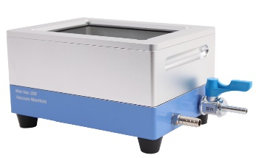 | 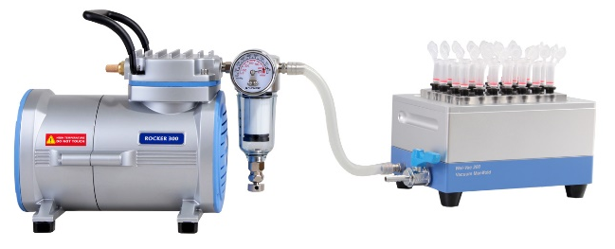
WelVac 200 | WelVac 210

Model | Standard Package Includes:
WelVac 200 | WelVac 200, Microplate Vacuum Manifold | x 1
WelVac 200 | Spin Column Adaptor Board | x 1
WelVac 200 | Luer Connector (25/pk) | x 1
WelVac 200 | Luer Stopper (25/pk) | x 1
WelVac 200 | Waste Tray | x 1
WelVac 200 | Allen Wrench | x 1
WelVac 200 | Sealing Kit (O-ring x 1, Gasket x 1) | x 1
WelVac 200 | Instruction Manual | x 1

Model | Standard Package Includes:
WelVac 210 | Rocker 300, Oil Free Vacuum Pump | x 1
WelVac 210 | WelVac 200, Microplate Vacuum Manifold | x 1
WelVac 210 | Spin Column Adaptor Board | x 1
WelVac 210 | Luer Connector (25/pk) | x 1
WelVac 210 | Luer Stopper (25/pk) | x 1
WelVac 210 | Waste Tray | x 1
WelVac 210 | Allen Wrench | x 1
WelVac 210 | Sealing Kit (O-ring x 1, Gasket x 1) | x 1
WelVac 210 | Silicone Tube | x 1
WelVac 210 | Instruction Manual | x 1
Main Part Diagram

- WelVac 200 Microplate Vacuum Manifold
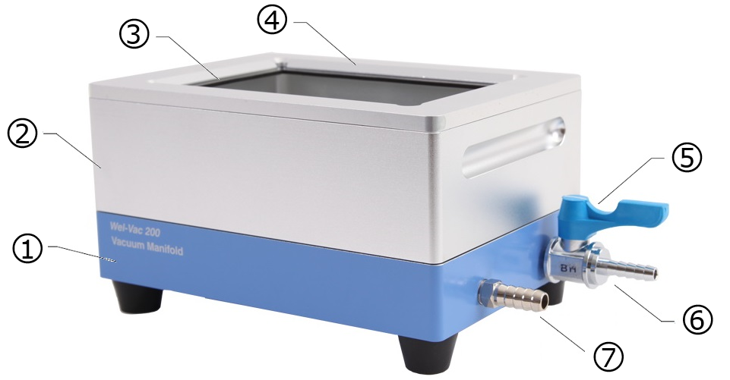
Position | Designation | Position | Designation
1 | Lower Chamber | 5 | Switch
2 | Upper Chamber | 6 | Vent
3 | Gasket | 7 | Vacuum Connector
4 | Top Ring
- WelVac 210 Microplate Vacuum Manifold System
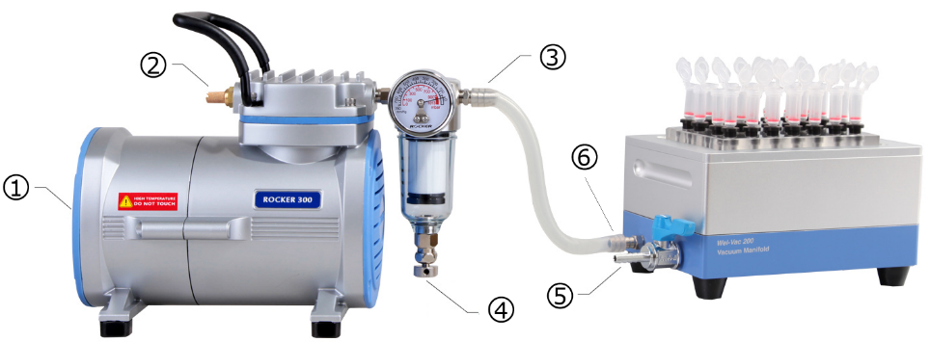
Position | Designation | Position | Designation
1 | Power Switch | 4 | Vacuum Regulator
2 | Muffler | 5 | Vent
3 | Inlet | 6 | Vacuum Connector
Installation and Operation

  - WelVac 200 Installation
- Ensure that the surface of gasket and O-ring are free from dirt or debris. Unclean gasket and O-ring would lead a poor airtight.
- Put a waste tray in lower chamber, then put the upper chamber on the top of it.
- Put 96-well extraction plate or spin column adaptor board on gasket of upper chamber according to type of extraction kit.
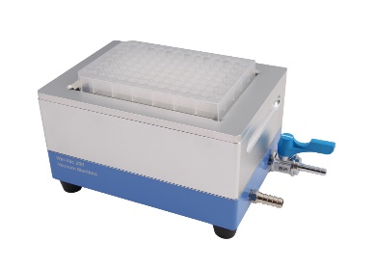 | 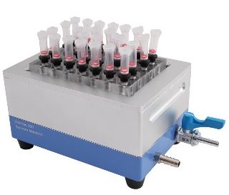 |  | 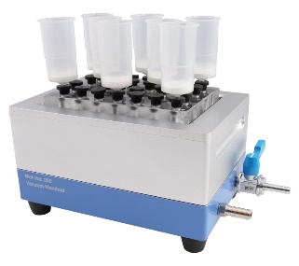
96-well Extraction Plate |  | Mini Spin Column x 24 |  | Maxi Spin Column x 8
  - WelVac 210 Installation
- Install the WelVac 200 according to Installation A. 1~3.
- Turn on the pump, block the inlet of pump and regulate the desired vacuum by adjusting vacuum regulator and turn the pump off.
- Connected the vacuum connector of installed WelVac 200 and inlet of Rocker 300 vacuum pump with silicon tube as shown in previous part.
- Appropriate vacuum degree is a key point to get efficient extraction. We suggest setting the system of the vacuum degree according to extraction protocol before filtration.

  - WelVac 210 Operation
- Before starting, please make sure the system is installed according to above mentioned A. and B.
- For extraction or purification kit, please follow the vacuum protocol in the relevant kit instruction manual.
- WelVac 200 also can be connected to local stationary vacuum source with optional vacuum regulator (167301-06) to adjust vacuum degree.
- Please rinse the WelVac 200 according to Maintenance after every use.
- Spin Column
- Put spin column adaptor board on gasket of upper chamber.
- Replace numbers of Luer stopper into connector on the spin column adaptor board according to number of spin column.
• Leave the Luer stopper on the unused hole of column adaptor board.
- Insert the spin columns firmly into the Luer connectors.
• Using same type columns to avoid different flow rate.
- Loading sample, turn on the vacuum pump and press lightly on the spin column adaptor board to engage the vacuum seal.
- When finished, please turn off the vacuum pump and open the vent to release the residual vacuum and prevent from cross-contamination.
• Do not release the pressure by opening the corner of the column adaptor board to prevent deformation of the manifold gasket.
• You can also remove residual droplets in the bottom of spin column by tap the top of adaptor board before releasing the vacuum.
- Remove the spin columns from column adaptor board and perform the elution step with centrifugation to ensure max. recovery.
- Remove the upper chamber and waste tray then disposal of the waste or utilize for further processing.
- 96-well Extraction Plate
- Put 96-well extraction plate on gasket of upper chamber.
- Loading sample, turn on the vacuum pump and press lightly on the extraction plate to engage the vacuum seal.
- When finished, please turn off the vacuum pump and open the vent to release the residual vacuum and prevent from cross-contamination.
• Do not release the pressure by opening the corner of the extraction plate to prevent deformation of the manifold gasket.
• You can also remove residual droplets in the bottom of extraction plate by tap the top of adaptor board before releasing the vacuum.
- Remove the extraction plate and perform the elution step with centrifugation to ensure max. recovery.
- Remove the upper chamber and waste tray then disposal of the waste or utilize for further processing.
• 1200 ml PES vacuum bottle is optional for handling large number of samples
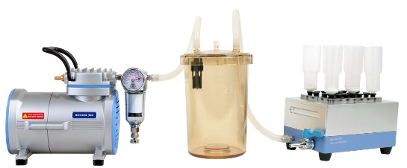 | 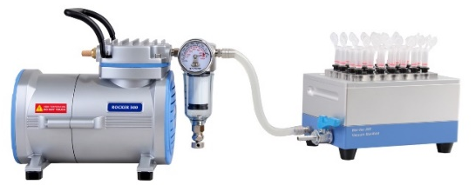
1200 ml PES Vacuum Bottle  (Optional) | WelVac 210 Assembly Diagram
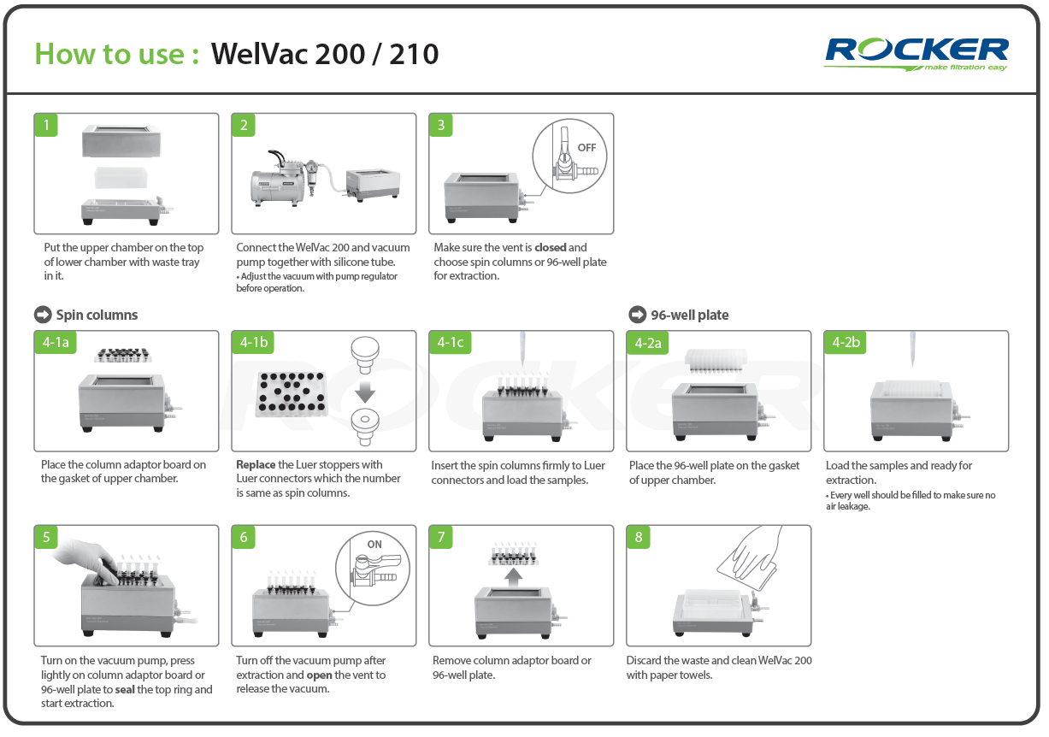
  - Replace the O-ring and Gasket
- When O-ring and gasket aged and vacuum can’t be achieved, replacing a new one.
- Both O-ring and gasket should be replaced at the same time.
- O-ring
- Remove existing O-ring from the bottom of the upper chamber.
- Ensure the new O-ring is free from dirt, debris, and particulate matter.
- Replace the new O-ring.
- Gasket
- Remove the 12 screws located on bottom of the upper chamber by Allen wrench.
- Separate the top ring, remove the old gasket and clean the top ring groove.
- Put the new gasket into the groove and put the top ring back. Please ensure that the bottom of the top ring groove is aligned cover gasket.
- Put the 12 screws and tighten screws at corners lightly and lock other screws back.
• Do not lock too tight to distort the top ring and lead a poor vacuum.
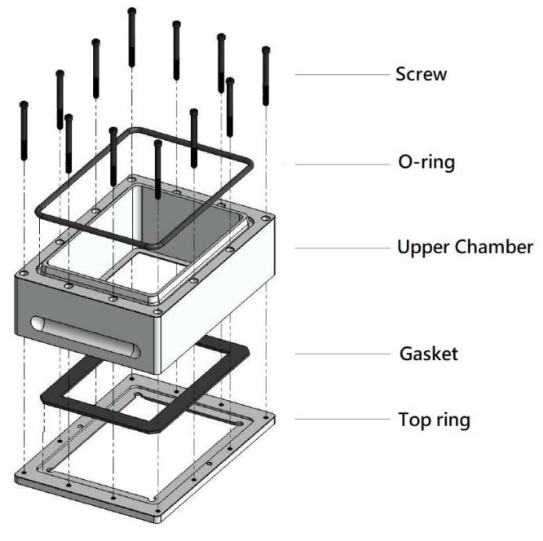
Maintenance
- Please cleaning the WelVac 200 vacuum manifold with water and either air dry or wipe with paper towels after every use. Do not use with any chemicals include solvent, bleach or abrasives.
- WelVac 200, silicone tube and accessories are autoclavable, please clean and autoclave (121°C, 1 bar, 20 min) if needed.
- The vacuum pump is not autoclavable. Please clean the surface by pure water, 75% ethanol or isopropanol (IPA).
- After finishing the experiment, please keep pumping the air for at least 2 minutes to withdraw the residual steam.
- If the gasket, O-ring are aged or damaged, please replace it. Do not smear any silicone oil or vacuum grease to the gaskets or other parts of the WelVac 200 vacuum manifold.
Troubleshooting

Problem | Reason and Solution
Pump  fails to start | - Wrong power supply Reconnect to specific power.  - Vacuum exists Release vacuum and restart pump.  - Switch is broken Contact distributor for assistance.
Poor vacuum | - Improperly vacuum setting Reset vacuum by regulator.  - Clogged muffler Clean or replace a new muffler.  - Unused Luer connectors Replaced by Luer stoppers.  - Opened vent valve Close the vent valve.  - Crack plates or adaptor board change a new one.  - Loose stoppers Replug the connectors and stoppers.  - Dirty or damage O-ring and gasket Clean or replace it.
Ordering Information
195210-11/22 | WelVac 210, Microplate Vacuum Manifold System,  AC110V, 60Hz (AC220V, 50Hz)
195200-00 | WelVac 200 Microplate Vacuum Manifold
167300-11/22 | Rocker 300, Vacuum Pump, AC110V, 60Hz (AC220V, 50Hz)
195200-42 | Spin Column Adapter Board - PC (24 holes)
195200-46 | Spin Column Adapter Board - Acrylic (24 holes)
195200-43 | Luer Connector (25/pk)
195200-44 | Luer Sotpper (25/pk)
195200-45 | Waste Tray
195200-35 | Allen Wrench
195200-60 | Sealing Kit
167301-06 | Vacuum regulator
197000-12 | 1200 ml PES Vacuum Bottle
167200-38 | Silicone Tube, Ø 6 x 12 mm, 1 m
167300-42 | Muffler for Rocker 300 / 400 / 410 / 430
Rocker Scientific Co., Ltd. / www.rocker.com.tw / +886-2-26033311 / RO-OPE195-EN202005-A01

